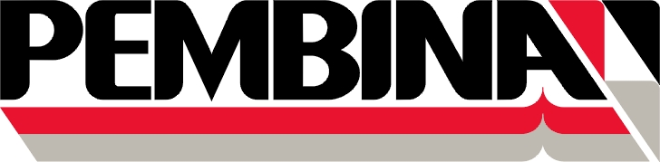

FOX TO NAMAO EXPANSION
July 15th, 2016
AUTHORIZED SIGNATURES

